MapD Analytics

Overview of the MapD Dashboard used at GTC 2018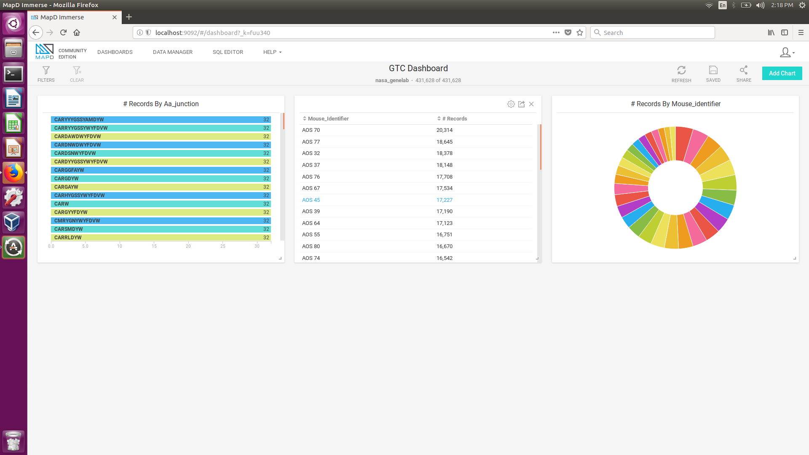

Here, I’ve highlighted three main graphs that summarize this project very clearly. First we have Graph 1, which labels each AA Junction and provides the number of mice genomes it is common in. For example, the first junction is common to all 32 mice, and as you move the down the graph the junction become more unique. This second graph easily shows the number of AA Junctions for each mice. AOS70 has 20,314 records while AOS18 has 8,759 records. Lastly, this last graph is another representation of Graph 2, with each part of the pie chart corresponding to a mice’s number of records. However, more interestingly with Chart 3, we can specific mice thus changing the previous two charts and overall dashboard. So Graph 3 almost serves as a controller for the other two graphs.

Example of SQL Queries used:

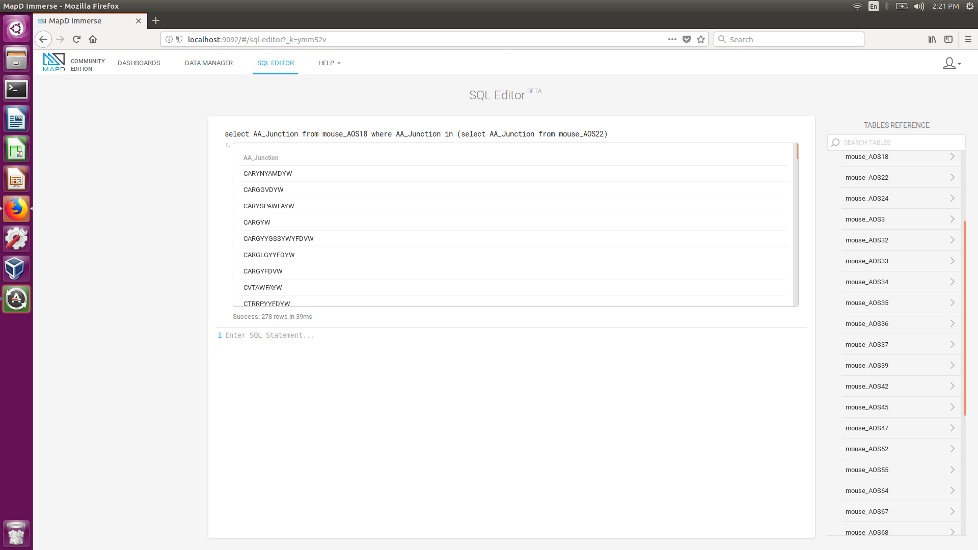

The main SQL query we used to compare two mice’s genomes is actually pretty simple, and can be generalized to any two mice’s genomes.

The SQL statement above is

select AA_Junction from mouse_AOS18 where AA_Junction in (select AA_Junction from mouse_AOS22)

And it provides the number of similar AA Sequences between Mouse 18 and Mouse 22.

However, a more general statement would be:

select AA_Junction from ***firstMouseID*** where AA_Junction in (select AA_Junction from ***secondMouseID***)